Lab2

Bùi Tấn Phát

#include<iostream>

using namespace std;

int main(){

int hangchuc, hangdv, i;

cout<<"Nhap vao so nguyen 2 chu so: ";

cin>>i;

if(i>9&i<100){

hangdv= i%10;

hangchuc= i/10;

if(hangdv\*hangchuc == 2\*(hangdv+hangchuc)){

cout<<"So "<<i<<" thoa yeu cau de bai";

}else{

cout<<"So "<<i<<" khong thoa yeu cau de bai";

}

}

else{

cout<<"Hay nhap lai";

return 0;

}

return 0;

}

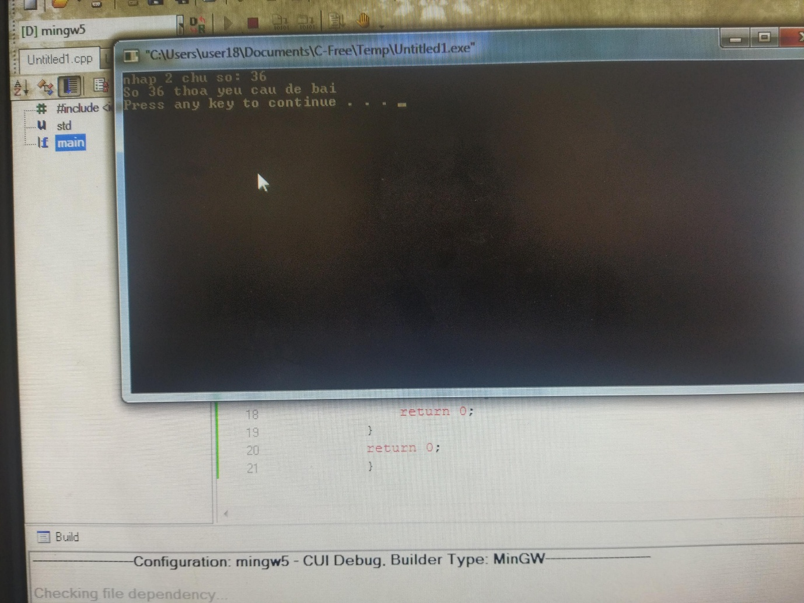

Bài 2

#include <iostream>

#include <math.h>

Using namespace std;

Bool checkNT(int n)

{

If(n<2) return false;

Int sq = sqrt(n);

For(int i=2;i <=sq ;i++){

If(n % i == 0){

Return false;

}

}

Return true;

}

Int main()

{

Int n;

Cout<<”Nhap n: “;

Cin>>n;

For(int i=1;i<n;i++){

If(checkNT(i) == true)

Cout<<” “<<i;

}

Return 0;

}

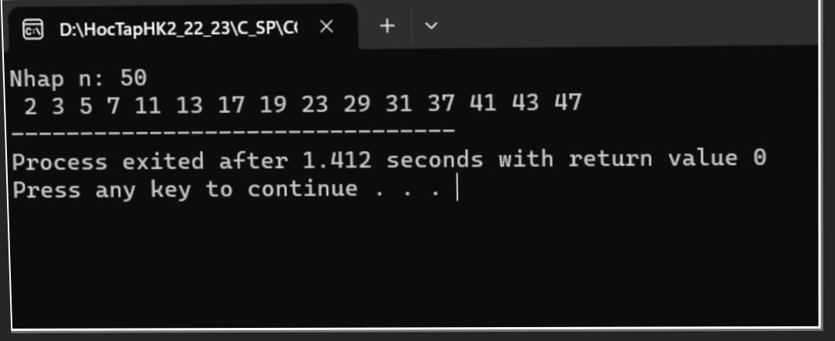

Bài 3

#include <iostream>

Using namespace std;

Char \*chuyenDoiNhiPhan(int n){

Char bit[50] = “00000000”;

Int i = 7;

While(n > 0){

Bit[i] = (n%2)+48;

i--;

n = n/2;

}

Return bit;

}

Int main(){

Int i;

For(i = 0; i <= 255; i++){

Char \*bit = chuyenDoiNhiPhan(i);

\*(bit+8) = 0;

Printf(“%s %d %c\n”,bit, i, i);

}

}

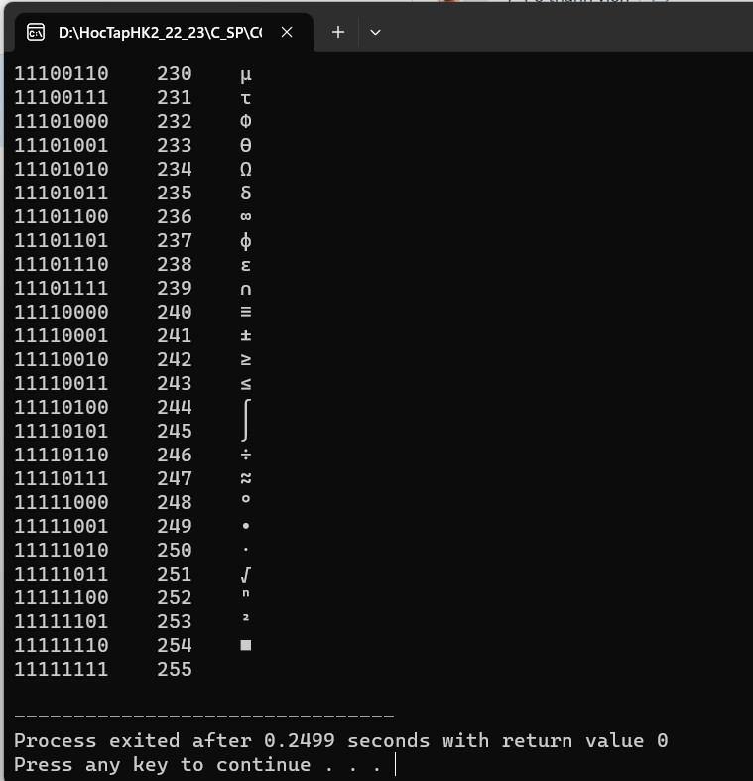

Bài 4

#include <iostream>

Using namespace std;

Int main(){

Int n, tmp;

Cout<<”Nhap n: “;

Cin>>n;

Int res= 0;

While(n>0){

Tmp= n % 10;

Res= res\* 10 + tmp;

N = n / 10;

}

Cout<<”So dao la: “<<res;

}

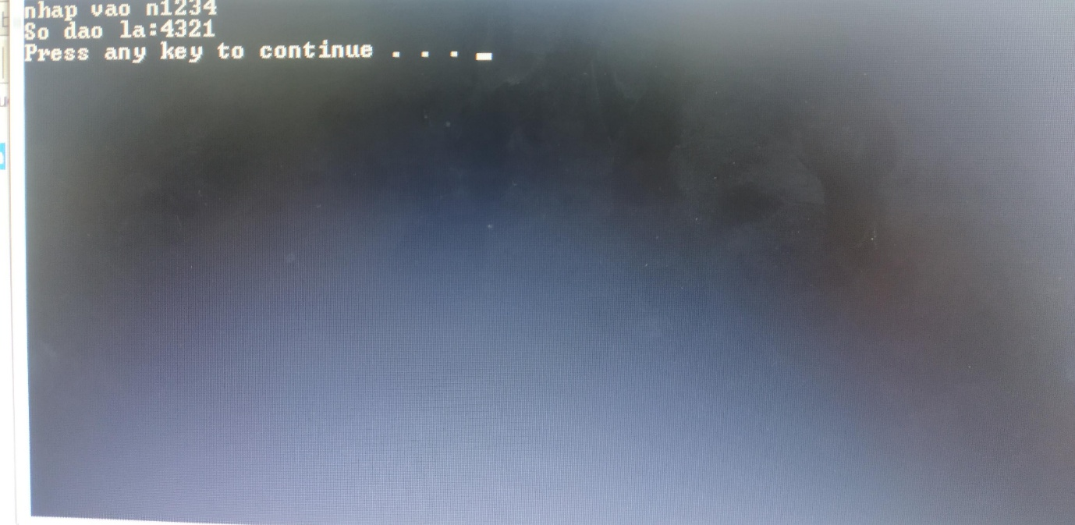

fl.•.t

Bài 5Cau 5:

#include<iostream>

Using namespace std;

Int main(){

Int n;

Cout <<”Nhap n :”; cin >> n;

Int dem =0;

Int tong =0;

Int temp= n;

While (temp>0){

Int x = temp %10;

Tong +=x;

Dem++;

Temp/=10;

}

Cout << “So luong chu so cua “ << n << “ la: “ <<dem<< endl;

Cout << “Tong cac chu so cua “ << n << “ la: “ <<tong << endl;

Return 0;

}

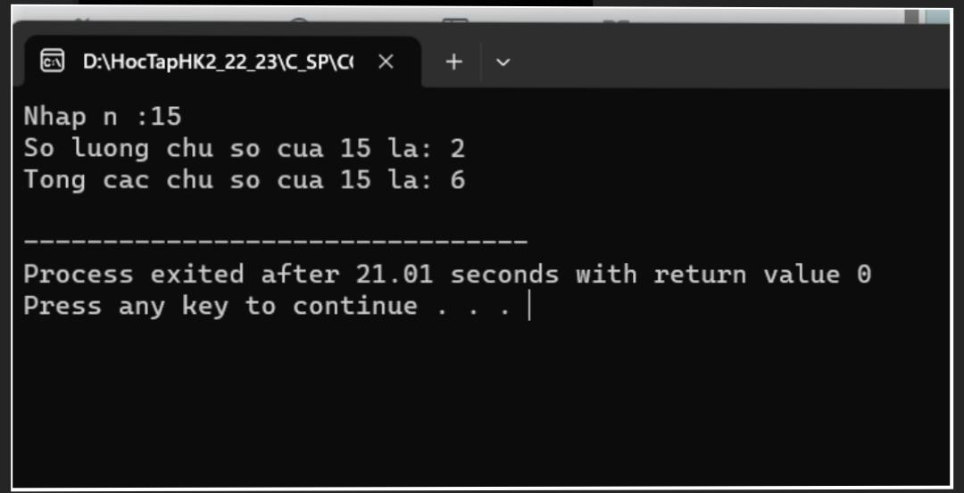

Bài 6

#include<iostream>

Using namespace std;

Int main(){

Long start,end;

Long tien1,tien2,tien3;

Long accesstime;

Float tong=0;

Cout<<”gio bat dau la: “;

Cin>>start;

Cout<<”gio ket thuc la: “;

Cin>>end;

If((start>=0)&&(end<=24)){

If((start>0)&&(end<=7)){

Tien1=300;

Tong=(end-start)\*tien1;

If((end-start)<7){

Tong=tong-(tong\*0.15);

}

Cout<<”thoi gian truy cap 1= “<<tong<<endl;

}

Else if(end>7){

Tien1=300;

Tong=(end-start)\*tien1;

If((end-start)>7){

Tong=tong-(tong\*0.15);

}

Cout<<”thoi gian truy cap 1= “<<tong<<endl;

}

If((end>7)&&(end<=17)){

Tien2=400;

Tong=tong+((end-start)\*tien2);

If((end-start)>6){

Tong=tong-(tong\*0.1);

}

Cout<<”thoi gian truy cap 2= “<<tong<<endl;

}

Else if(end>=17){

Tien2=400;

Tong=tong+((end-start)\*tien2);

If((end-start)>6){

Tong=tong-(tong\*0.1);

}

Cout<<”thoi gian truy cap 2= “<<tong<<endl;

}

If((end>17)&&(end<=24)){

Tien3=350;

Tong=tong+((end-start)\*tien3);

If((end-start)>4){

Tong=tong-(tong\*0.12);

}

Cout<<”thoi gian truy cap 3= “<<tong;

}

}

Return 0;

}

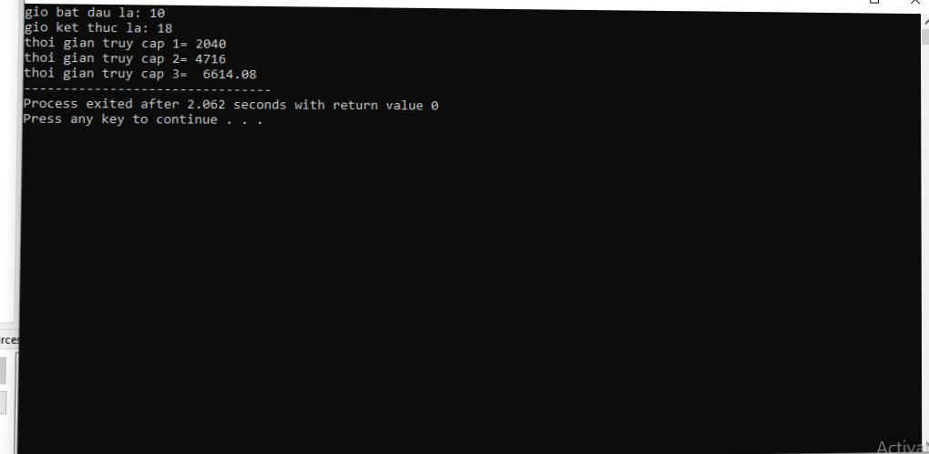

Bài 7

#include <iostream>

Using namespace std;

Int main(){

Int x;

Char c;

Do{

Cout<<”Loai phong thue: “;

Cin>>c;

}while(c!=’a’&&c!=’b’&&c!=’c’);

Do{

Cout<<”\nSo ngay thue: “;

Cin>>x;

}

While(x<1);

Float A=250.000,B=200.000,C=150.000;

Float A1=0.1,B1=0.08,C1=0.08;

Float sotien;

If(x<=12&&x>=1){

Sotien = (c==’a’) ? (A\*x)☹(c==’b’) ? (B \* x)☹C \* x));

}

Else{

Sotien=(c==’a’) ? (A\*A1\*x)☹(c==’b’) ? (B\*B1\*x)☹C\*C1\*x));

}

Cout<<”\nSo tien nhan duoc la: “<<sotien;

Return 0;

}

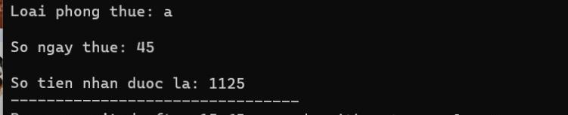

Bài 8

#include <iostream>

Using namespace std;

Bool isValidDate(int day, int month, int year) {

If (year < 0 || month < 1 || month > 12 || day < 1) {

Return false;

}

Int daysInMonth[] = {0, 31, 28, 31, 30, 31, 30, 31, 31, 30, 31, 30, 31};

If ((year % 4 == 0 && year % 100 != 0) || year % 400 == 0) {

daysInMonth[2] = 29;

}

Return day <= daysInMonth[month];

}

Void findNextDay(int &day, int &month, int &year) {

Int daysInMonth[] = {0, 31, 28, 31, 30, 31, 30, 31, 31, 30, 31, 30, 31};

If ((year % 4 == 0 && year % 100 != 0) || year % 400 == 0) {

daysInMonth[2] = 29;

}

Day++;

If (day > daysInMonth[month]) {

Day = 1;

Month++;

If (month > 12) {

Month = 1;

Year++;

}

}

}

Void findPreviousDay(int &day, int &month, int &year) {

Int daysInMonth[] = {0, 31, 28, 31, 30, 31, 30, 31, 31, 30, 31, 30, 31};

If ((year % 4 == 0 && year % 100 != 0) || year % 400 == 0) {

daysInMonth[2] = 29;

}

Day--;

If (day < 1) {

Month--;

If (month < 1) {

Month = 12;

Year--;

}

Day = daysInMonth[month];

}

}

Int main() {

Int day, month, year;

Cout << “Nhap ngay (1-31): “;

Cin >> day;

Cout << “Nhap thang (1-12): “;

Cin >> month;

Cout << “Nhap nam: “;

Cin >> year;

If (isValidDate(day, month, year)) {

findNextDay(day, month, year);

cout << “Ngay hom sau la: “ << day << “/” << month << “/” << year << endl;

} else {

Cout << “Ngay thang nam khong hop le!” << endl;

}

Return 0;

}

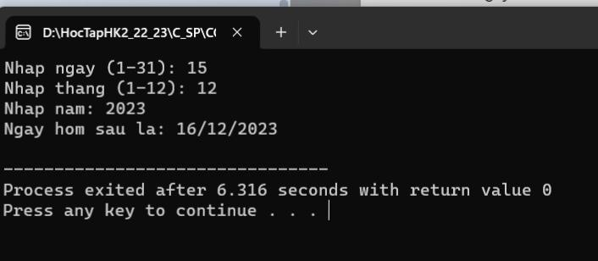

Bài 9

#include<iostream>

Using namespace std;

Int main() {

Int km;

Float total1,total2,total3;

Cout << “Nhap so km: “;

Cin >> km;

Total2 = 15.000+13.500 \* (km-1);

Total3 = 15.000 + 13.500 \* 4 + 11.000 \* (km – 5);

Total1 = total3 \* (90 / 100);

If (km == 1)

Cout << “Ban can tra: 15.000” << endl;

Else if ((km>=2)&&(km<=5))

Cout<<”Ban can tra: 15.000+13.500\*”<<(km-1)<<” = “<<total2<<endl;

Else

{

If (km > 12) {

Cout << “Ban can tra: 15.000+13.500\*4+11.000\*” << (km – 5) << “ = “ << total3 << endl;

}

Else

Cout << “So tien ban tra: 15.000+13.500\*4+11.000\*” << (km – 5) << “ = “ << total3 << endl;

}

Return 0;

}

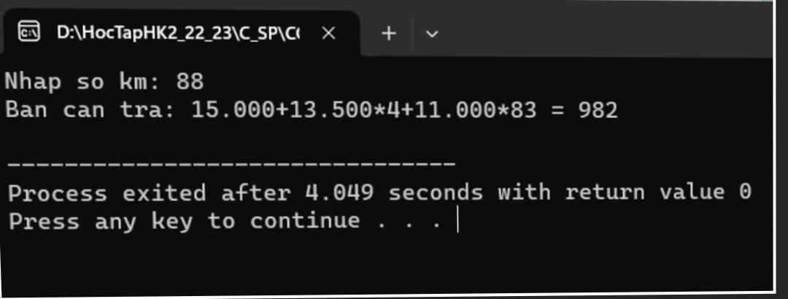

Bài 10

#include <iostream>

Using namespace std;

Int main()

{

Float diemT;

Float diemV;

Float diemA;

Float dtb;

Cout<<”Nhap diem toan: “;

Cin>>diemT;

Cout<<”Nhap diem van: “;

Cin>>diemV;

Cout<<”Nhap diem anh: “;

Cin>>diemA;

Dtb = (diemT + diemV + diemA) / 3;

Cout<<”Diem trung binh la: “<<dtb;

If (dtb < 3.0){

Cout<<” KEM”;

}else if ((3.0 <= dtb)&&(dtb < 5.0)){

Cout<<” YEU”;

}else if ((5.0 <= dtb)&&(dtb < 6.5)){

Cout<<” TB”;

}else if ((6.5 <= dtb)&&(dtb < 8.0)){

Cout<<” KHA”;

}else if ((8.0 <= dtb)&&(dtb < 9.0)){

Cout<<” GIOI”;

}else{

Cout<<” XUAT SAC”;

}

Return 0;

}

